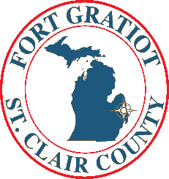
For Immediate Release
March 27, 2020

Coronavirus Information and Fort Gratiot Closure

Fort Gratiot Municipal Offices will continue to be closed to following the Executive Order issued by Governor Whitmer in an effort to minimize the spread of COVID-19. Updates will be posted on our website, fortgratiot.us and Facebook, Fort Gratiot Charter Township and Instagram, fortgratiot1866.

The office will not be staffed during this closure; however, employees will be working remotely checking their messages and emails throughout the day. If residents have any issues, please contact the office at (810) 385-4489, and listen to the message to be transferred to the correct department. Alternatively, contact Supervisor Rob Crawford at (810) 650-0234 or rcrawford@fortgratiot.us, Clerk Bob Buechler at (810) 841-4426 or rbuechler@fortgratiot.us, or Treasurer Jaime Oprita, joprita@fortgratiot.us. Please contact DPW Superintendent Greg Randall at (810) 650-0208 or Assistant Superintendent, Jeff Parent at (810) 650-3119 with any emergencies involving the water and/or sewer system.

Additional Information

Call 911 for all emergencies.

DNR has prohibited open burning, therefore we can not issue burning permits at this time.

Further area information and updates regarding COVID-19 may be obtained at
www.scchealth.co

Please help us by:

- Staying home, Staying Safe.
- Practice social distancing by leaving six feet of space between you and another person.
- Visit you family and friends by calling them.

Thank you for your cooperation, together we can get through this.

Supervisor Rob Crawford, (810) 650-0234, rcrawford@fortgratiot.us
Clerk Bob Buechler, (810) 841-4426, rbuechler@fortgratiot.us
Treasurer Jaime Oprita, joprita@fortgratiot.us

